**JFSD: A-Z of Back-end and Database Development**

**Day 5 : 20 Jul. 24**

In Java we can create more than one thread using

1. Extends Thread class
2. Implements Runnable interface

Runnable is a interface which contains one method ie run() and it is an abstract method.

If we want to perform any task by multiple thread then we need to create only one class.

Task like booking ticket, paying the amount of ticker, transfer the amount, add the product in a cart.

Number of clients is equal to number of thread.

Synchronization : it is use to block or lock or allow only one thread to use all resources at time.

To achieve synchronization we need to use synchronized keyword. this keyword we can use with method or block

String : String is a pre defined class part of lang package.

We can create the string class object using two ways

1. String str1 = “Welcome to java training”; literal style or variable declaration style.
2. String str2=new String(“Welcome to Java Training”); object created.

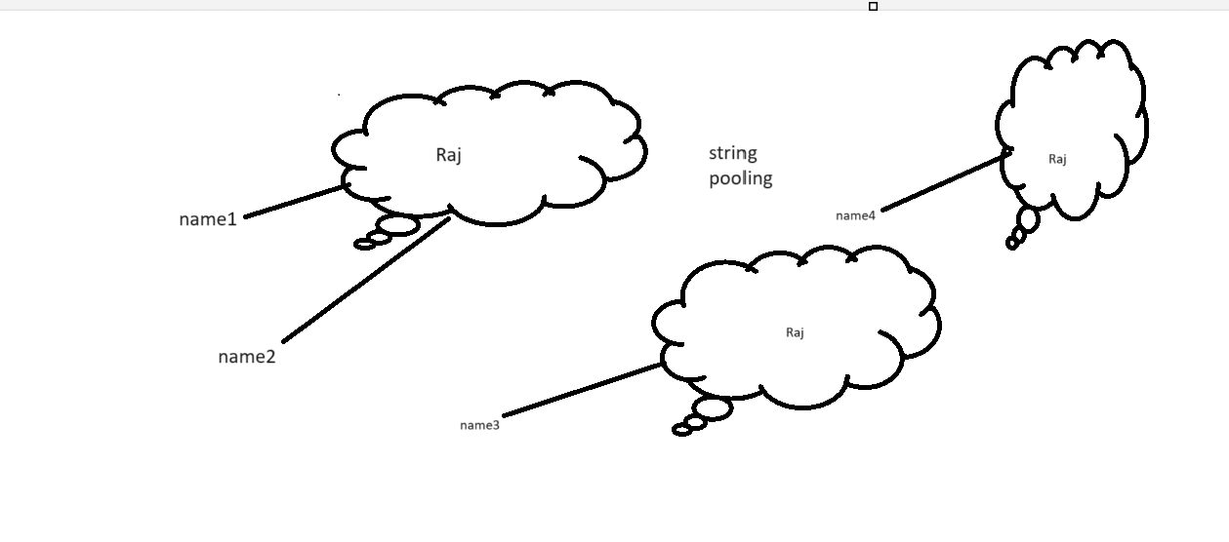

== it check value as well as memory or memory code.

equals method : this method is use to check value not memory code.

String is known as immutable(can’t change the value) class.

Below two classes is known as mutable string class.

StringBuffer : method are synchronized. Thread safe but slow in performance.

StringBuilder : method is not synchronized. Not thread safe but fast in performance.

Wrapper classes

Java provided totally 8 types of wrapper classes.

Primitive data types Wrapper classes

byte Byte

short Short

int Integer

long Long

float Float

double Double

char Character

boolean Boolean

it is use to convert primitive to object and vice-versa.

It is use to do type casting.

**IO Package**

File handling program

Stream : flow of data or abstraction between source and destination

In Java we can do io or stream operation using two ways

1. Byte wise
2. Char wise

Stream

byte char

Input Output Input Output

InputStream OutputStream Reader Writer 🡪

Abstract classes

DataInputStream DataOutputStream ,InputStreamReaderOuptutSteramWriter

FileInputStream FileOutputStream BufferedReader BufferedWriter

BufferedInputStream BufferedOutputStream FileReader FileWriter

ObjectInputStream ObjectOutputStream

PrintStream PrintWriter

System.out.println

System.in

in, out and err : these are property or reference part of System class.

static and final

in it is InputStream Reference

out : PrintStream

err : PrintStream

System.in is consider as Inputstream class reference. InputStream always refer standard input device ie keyword.

System.out : which refer to Standard output device ie console. It is consider as PrintStream class reference.

Object -🡪

Identity 🡪 reference

Property -🡪 variable we want to store object property in external file.

Behaviour 🡪 methods

Object Serialization : converting object into byte format or serializable format.

Marker interface : the interface contains zero method or no method is known as marker interface.

Serializable.